#Week (1) Configuring SSL VPN
1- create user group and add local user to it
User & Authentication → User Definition → Create New
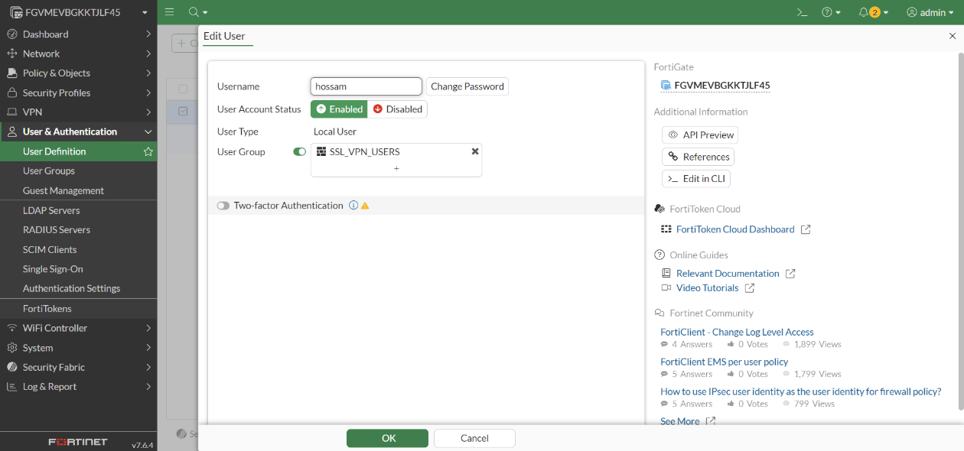
User & Authentication → User Groups → Create New
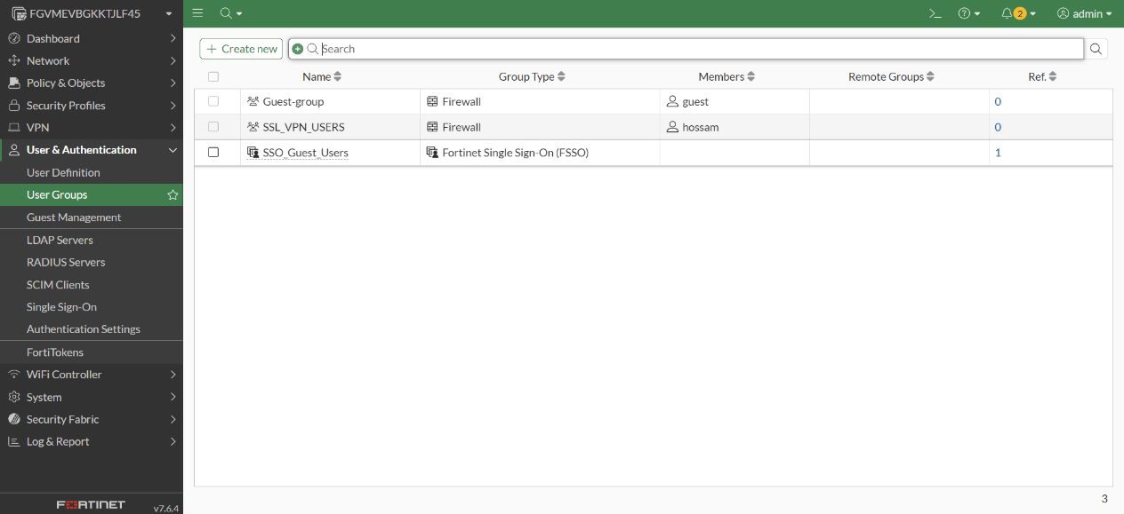

2-configure SSL-VPN settings
VPN → SSL-VPN Settings
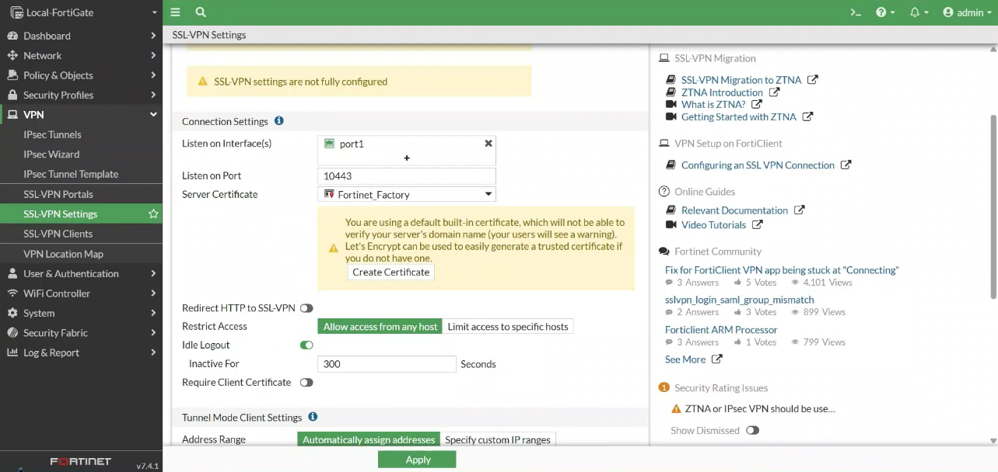
In the Authentication/Portal Mapping section, select All Other Users/Groups, and then click Edit.
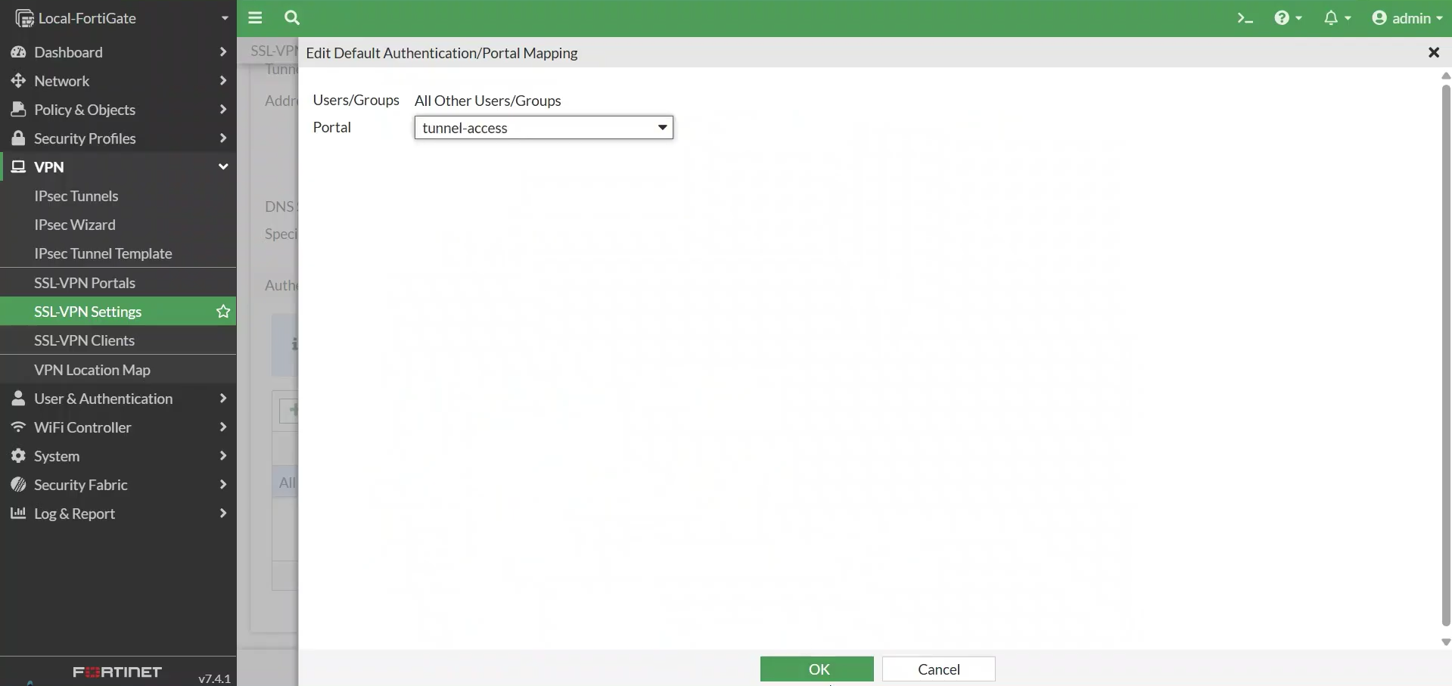

3- configure SSL-VPN Portal
VPN > SSL-VPN Portals. Select the tunnel-access portal and click Edit. 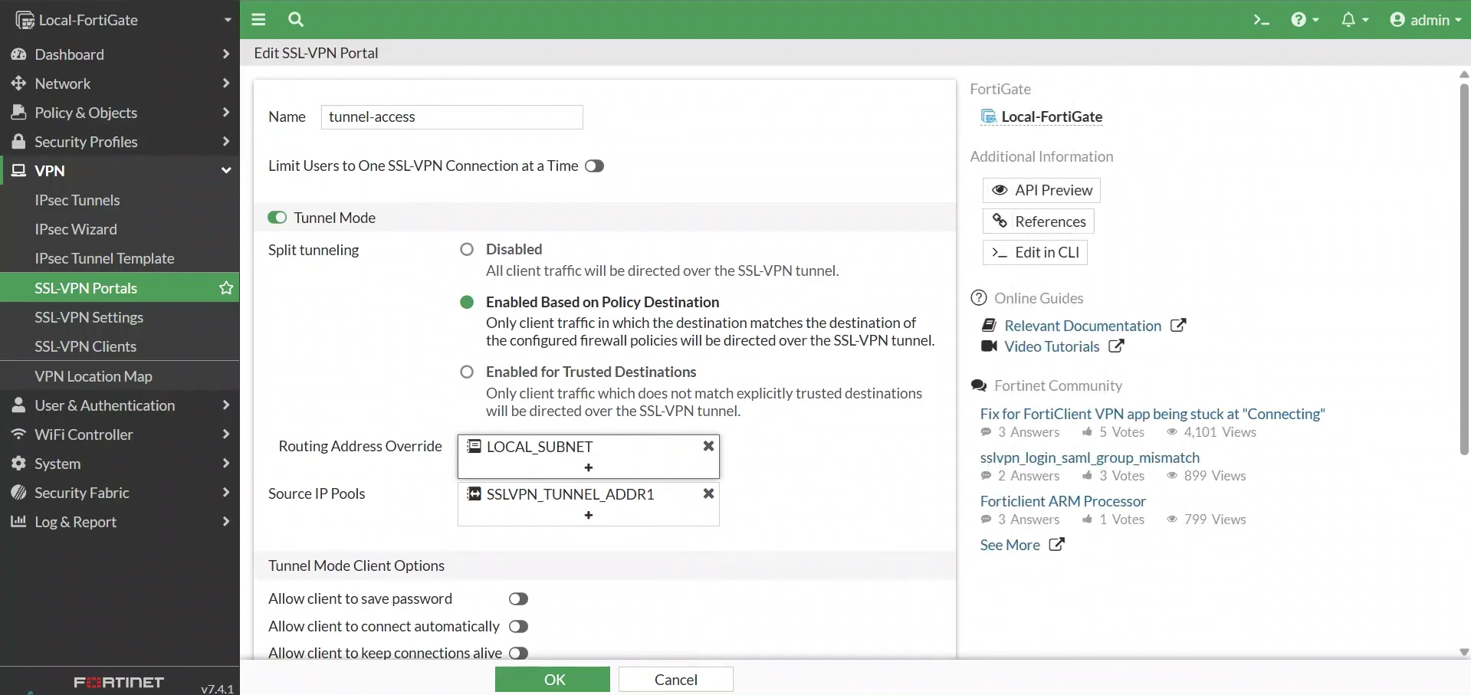
4- create firewall policy
Policy & Objects → Firewall Policy → Create New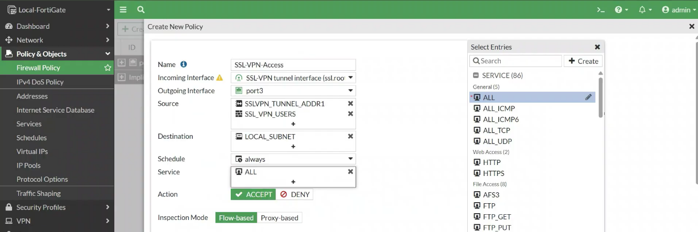
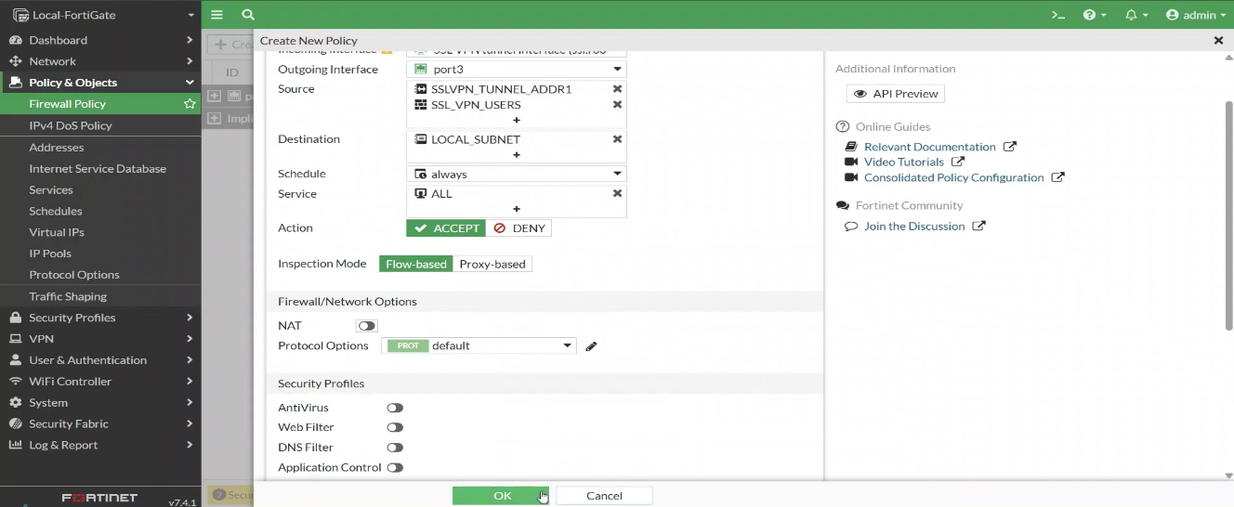
5- configure FortiClient
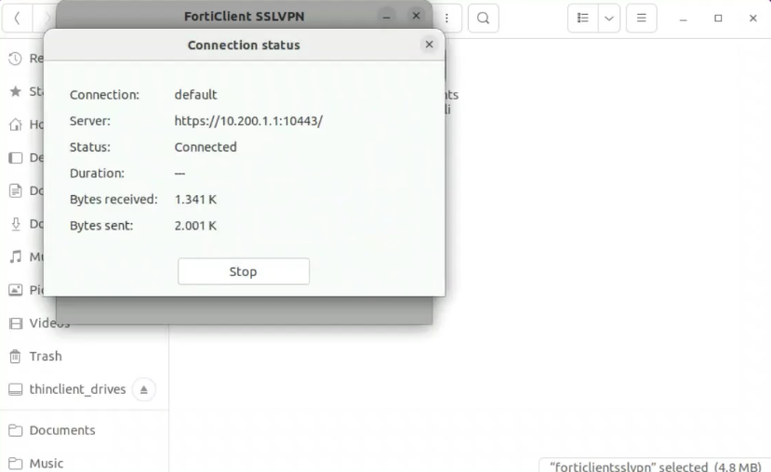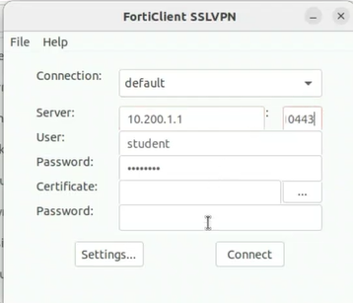
Now SSL VPN is ready for testing and Monitoring
